

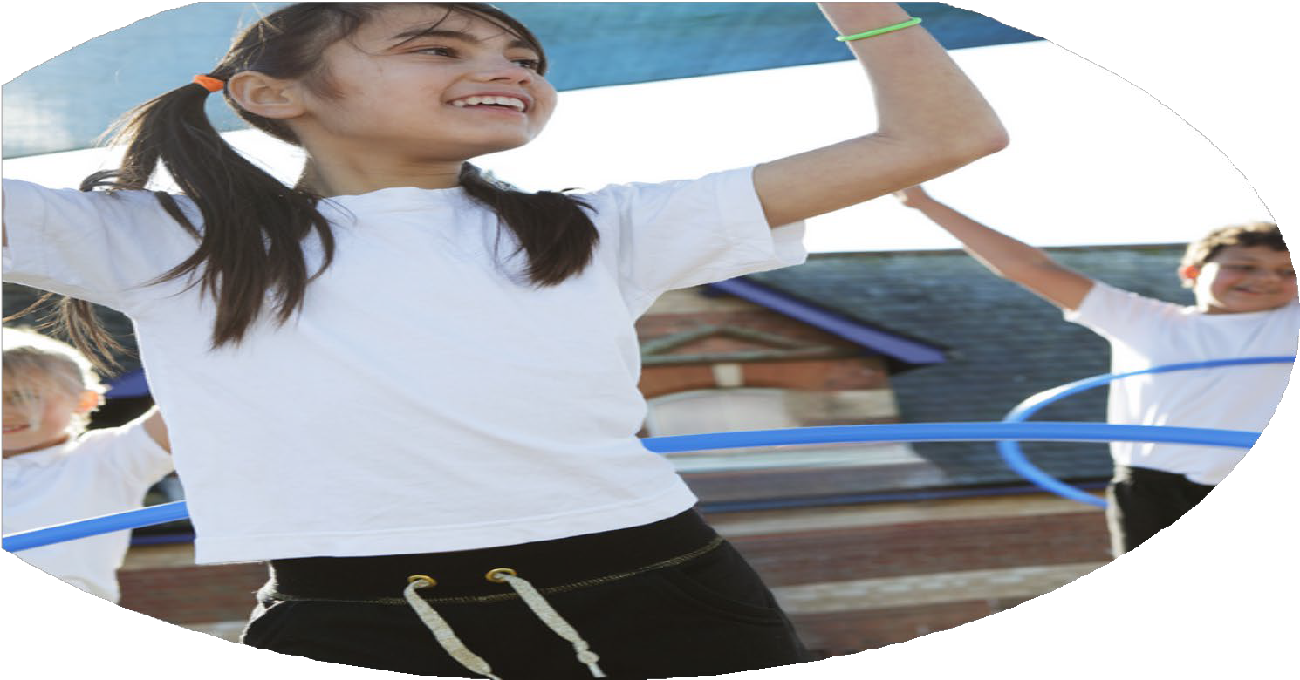





PE Funding

Evaluation Form

Commissioned by

Created by

Images courtesy of Youth Sport Trust

PE Funding Evaluation Form

It is intended that this template should be used as preparation for the completion of the statutory digital reporting tool being introduced this academic year. You can upload data (including swimming) from this template onto this platform once it becomes accessible.
Before you decide how you are going to use the funding for this academic year you should reflect and evaluate the impact of your use of the funding in 2024-25.
All spending of the funding must conform with the terms outlined in the Conditions of Grant document. The template is a working document that you can amend/update during the year.
Based on your evaluation of last year’s funding you should decide what you intend to do this academic year, how you will do it, and what impact you expect it to have.

It is important that the funding is used effectively and based on your school’s needs.
You must use the funding to make additional and sustainable improvements to the PE and sport in your school. You must develop and add to the PESSPA activities that your school already offers.

Summative digital reporting from June 2025 will continue to include swimming and water safety information therefore funding can be used to provide top-up lessons where necessary to ensure pupils meet national curriculum swimming requirements.

Sports Premium Funding Key Indicators for 24-25
1. Increased confidence, knowledge and skills of all staff in teaching PE and sport
2. The engagement of all pupils in regular physical activity - the Chief Medical Officer guidelines recommend that all children and young people aged 5 to 18 engage in at least 60 minutes of physical activity a day, of which 30 minutes should be in school
3. The profile of PE and sport is raised across the school as a tool for whole-school improvement
4. Broader experience of a range of sports and activities offered to all pupils
5. Increased participation in competitive sport

What went well? | How do you know? | What didn’t go well? | How do you know?
1. Increased confidence, knowledge and skills of all staff in teaching PE and sport
PE network meetings with the Trust started and Sarah Herbert attended.  We shared good practice and looked at SEND within PE. | I am now part of the PE steering group for 25/26.  SEND adaptations to be added to intent documents/ MTP’s and lesson plans where applicable. | Finding the time to create PE Intent documents | Only Gymnastics intent documents have been completed.
Network meetings through Nottingham City with Nick Robb were also attended by Sarah Herbert | Outdoor and adventurous lesson ideas.
PE observations in Pentecost 2 -SH observed lessons from years 1 to 5. Looking at the amount of physical activity in each lesson and how staff delivered objectives, including the language they used. | It was good to get an overview of PE lessons – and it helped to shape the areas of development for next year.  Lots of good language used regarding ‘character words’ within PE – eg. Resilience, self-belief, courage etc. | Some observations of PE lessons were not high quality. Too much time was spent getting changed for lessons and too much standing and talking time. | Some classes only had 7-10 minutes of actual physical activity in a lesson.
Using Know, Show, Grow (KSG) posters to display Learning objectives within PE lessons | Most teachers are consistently using KSG posters. The evidence is in PE books and pupil voice. | Some staff are not consistently using KSG, and this will be encouraged next year. | PE books and pupil voice
CPD: SH and Clare S attended a Dance workshop | Clare S, yr 2 teacher said she gained so much confidence by attending workshop. Her Dance lessons have improved. | No PE staff meetings this year because PE lead was on a secondment for OAK National academy. | There was no time for PE staff meetings.
CPD -SH – ‘Youth Sport Trust conference’, and ‘Well schools Trust’, and ‘Models Based Practice’ courses attended by Sarah Herbert | Gained interesting and essential advice and ideas which will be shared with staff and the trust over the coming year.
CPD – Reception and year 1 staff received CPD from Notts county football club -they delivered football based games for half a term to each class. | Staff reported that the sessions were well run, and they gained confidence teaching games. | Some class teachers did not receive PE specific CPD this year. This will be addressed next year.
2 hours of PE a week for all classes.  All year groups cover Gymnastics, dance, games, outdoor and adventurous activities. Year groups 4-6 also swim. | PE is timetabled to ensure all children from years 1 -6 receive the recommended 2 hours a week. The reception class has 1 hour per week, and nursery PE is approx. 30-45 minutes.
High quality lessons from Complete PE that focus on physical, cognitive, social and emotional success. | We continue to use the Complete PE scheme as a starting point for most PE lessons. Staff like the use of videos to demonstrate lesson set up.
Resources audit: PE cupboard was given an overhaul and new stock ordered. | We have plenty of large balls, skipping ropes, cones, floor spots, athletics equipment etc, and some more unusual resources – indoor kurling/ boccia kits etc. | We run out of tennis balls regularly.  Each class will be given their own set next year.
Athletics data and class assessment pages. | All staff report on athletics data – timed runs/ long jump, speed bounce etc.  Teachers fill in Whole class assessment pages at least twice as part of every unit (every half term). These monitor more and less able and highlight a PSHE (grow) focus noting who has exceeded with this aspect of PE.
2. The engagement of all pupils in regular physical activity - the Chief Medical Officer guidelines recommend that all children and young people aged 5 to 18 engage in at least 60 minutes of physical activity a day, of which 30 minutes should be in school
Continued playground provision ensures pupils have opportunities for physical activity at break times and lunchtimes, and thus count this towards pupil activity for 60 minutes per day. 30 minutes of which should be within school time. | Two TA’s are given responsibility for resources on the playgrounds. Equipment is well used and pupils report that they enjoy the choice of activities. | Football dominates KS 2 playground at lunchtimes. We will look more closely at this next year. | This can cause behavioral problems when not monitored.
Friday Music day on KS 1 yard. | Pupils look forward to Friday dance saessions.
Targeting least active pupils | Lunchtime staff look for inactive pupils and encourage them to play active games.
Yr 6 ‘buddy’ system is in place. Yr 6 pupils received leadership training, and they support p[lay with reception class children throughout the year. | Both Reception and year 6 staff and pupils agree that this is time well spent.
Staff activity sessions promote enjoyment of being active and help to ensure staff value physical activity. This, in turn, impacts pupils playtime sessions and PE lessons. | Walking lunchtimes, staff yoga and Pilates.
End of playtime exercises – AT the end of each playtime, staff lead the playground in basic stretch and strength exercises.  Also, Brain breaks as part of lessons. | This can be seen to be done at the end of breaks, just before pupils are asked to line up.  Pupils enjoy brain breaks | Brain breaks need to be consistently performed to help pupils achive their potential in all lessons.
3. The profile of PE and sport is raised across the school as a tool for whole-school improvement
Special Mention assembly and Star in the jar and house points are examples of whole school initiatives used to celebrate success in all areas of the curriculum, including PE and physical activity. | Pupils are nominated for excellence, effort and improvement. Pupils are encouraged to bring in certificates and achievements from physical activity they have participated in outside of school.
Developing life skills within PE lessons improves behaviour and celebrates learning of the whole child. | This is completed through the ‘Grow’ section of Know, show, grow planning page that teachers produce to share learning objectives with pupils.
Brain breaks | Some teachers understand the importance of and use regular Brain breaks to maximize growing brain cells and improve learning and memory.
Parent newsletter to inform what’s happening in PESSPA | Termly newsletter emailed to all parents.
PE display in the corridor | Displays sports day pictures, or photos of special sports events. | This was not updated regularly enough, and this will be addressed next year. Consider photos of children taking part in Physical activity outside of school .
Sports Ambassadors – 4 pupils from year 6 represent their peers. They sometimes create Playground challenges. | Miss Barry held some meetings to discuss PESSPA with the group.
Align PE targets with school development plan | Excellent teaching is promoted in all subjects
Sports Day – a celebration of PESSPA | A successful sports day, where life skills such as determination, effort and friendship were rewarded.
4. Broader experience of a range of sports and activities offered to all pupils
Bikeability offered to pupils in years 5 and 6. | 14 pupils passed level 2 – riding on the road.
Me vs ME personal best athletics challenges delivered to years 4 and 5. | Pupils enjoyed the ideas of personal bests and worked hard to improve their scores.
Sports and physical activity events attended at Harvey Hadden – festivals and non-competitive events ran throughout the year, including handball, dodgeball, multisports. | Most children in years 5 and 6 represented school in at least one event.  Year 2 attended a cricket festival.  All events celebrated in school assemblies.
Girls active survey | Completed in June 2025. Results showed that 87% of pupils enjoy PE, citing being with friends and getting fit and healthy as the top motivators for physical activity. | General pupil survey – with regard to activities they would like to see on the curriculum. | This will be addressed next year.
Yearly overview of PE units is constantly monitored and updated | A yearly overview outlines which units staff deliver in each year group. It includes a broad range of activities including, gym, dance, games, OAA and swimming. It also includes more general themes such as Game Sense, Health and wellbeing and attack v defence.
Swimming data is above national average | 81% can swim 25m or more  84% can swim a range of strokes, even if only for a short distance  88% can perform self-rescue techniques.
Extra curricular offer includes boys and girls football, KS 1 games, basketball, multisports, athletics and targeted SEND multisport sessions. | Need to ask the office for a % figure of pupils participating in these activities, but all sessions generally had at least 12 pupils taking part.
5. Increased participation in competitive sport
Competitive events have included: athletics, football, cross country running, team relay running and netball | Won silver medals at Team relay running  Yr 6 athletics – Quad kids – silver medals  Indoor athletics for years 5-6 – 6th out of 40 schools  Cross country event – 2 pupils were in the top ten of about 100 runners.  Football team came  Netballers enjoyed their games at The High school.  All events were celebrated in school assemblies.
Intra school competition within PE lessons | Teachers include friendly competition as part of some PE lessons, and personal best as part of some lessons.
Use of minibuses for sports events | This is costly, but essential to access some events. Where possible staff use cars to transport children with parental support.

Sports Premium Funding Key Indicators for 25-26
1. Increased confidence, knowledge and skills of all staff in teaching PE and sport
2. The engagement of all pupils in regular physical activity – the Chief Medical Officer guidelines recommend that all children and young people aged 5 to 18 engage in at least 60 minutes of physical activity a day, of which 30 minutes should be in school
3. The profile of PE and sport is raised across the school as a tool for whole-school improvement
4. Broader experience of a range of sports and activities offered to all pupils
5. Increased participation in competitive sport

What are your plans for 2025/26? | How are you going to action and achieve these plans?
Intent | Implementation
Continue completing Intent documents to support teacher’s planning and achieve consistency across all school subject planning. | Use PPA time to complete documents, and seek advice from other staff.
Half termly updates to staff and wider trust schools with brain break ideas, current best practices and PE updates. | Use PPA time
Gather pupil voice on all things PE and school sport  Gather staff voice on their perceptions of PESSPA, and their perceived strengths and weaknesses. | A generic survey for PE asking what pupils would like, and include KS 1  Gather evidence from the YST Girls active survey again in June 26.
Explore the impact of a ‘well school’ as part of a ‘well trust’ with a focus on PESSPA. | Through PE steering groups and network meetings
Review of teacher’s PE planning
Review of PE assessment
Update PE resources
Continue to attend events and competitions – aim to have all pupils represent school at least once each year.
Apply for the school games mark
Staff training and meetings to support use of Oak National academy resources
Plan enrichment days to offer a broad range of experiences eg. Hula hooping, skipping, climbing and archery

What impact/intended impact/sustainability are you  expecting? | How will you know? What evidence do you have or  expect to have?

What impact/sustainability have you seen? | What evidence do you have?

