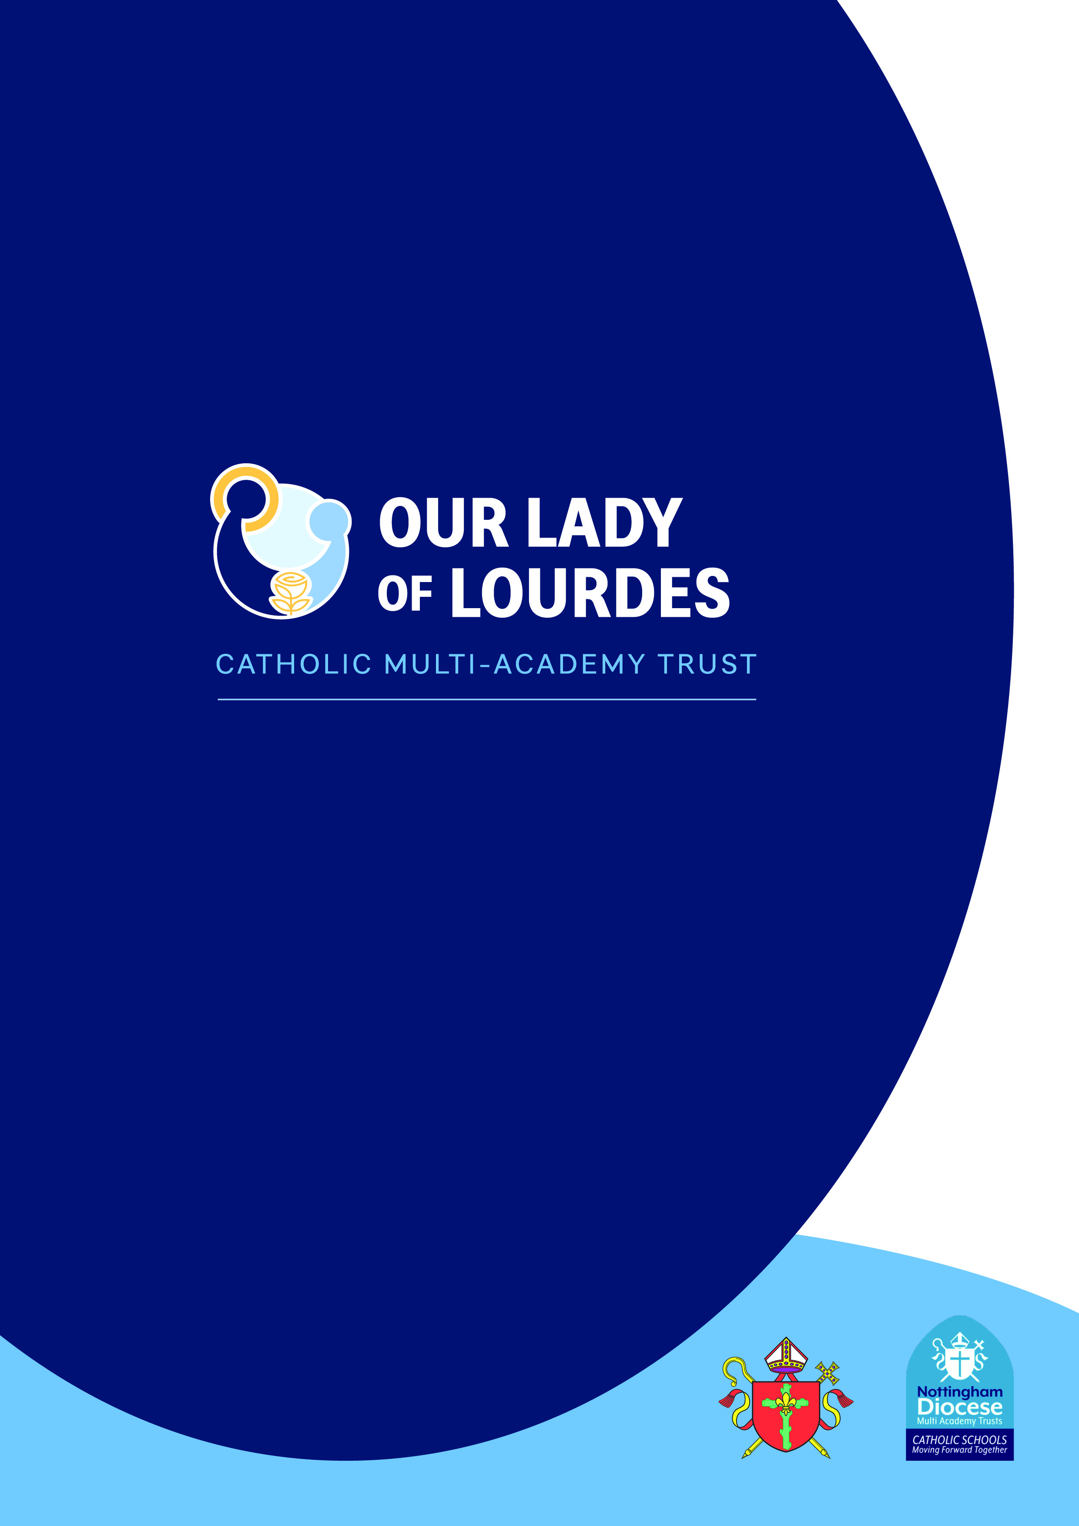

Trust, School and Home Agreement

**Trust Agreement**

**The Our Lady of Lourdes Catholic Multi Academy Trust**

Our Lady of Lourdes Catholic Multi-Academy Trust was formed on 1 September 2018 of the 21 Catholic primary and secondary schools in Nottingham City and Nottinghamshire. The 15 Catholic schools in Lincolnshire joined OLoL on 1 September 2022, creating a Trust of 36 Catholic schools. We place the person and teachings of Christ at the centre of everything we do and work in close partnership with the Diocese of Nottingham and our sister Catholic MATs.

**Our Lady of Lourdes Catholic Multi Academy Trust Mission Statement**

We are a partnership of Catholic schools. Our aim is to provide the very best Catholic education for all in our community and so improve life chances through spiritual, academic and social development.

By placing the person and teachings of Jesus Christ at the centre of all that we do we will:

* Follow the example of Our Lady of Lourdes by nurturing everyone in a spirit of compassion, service and healing.
* Working together so that we can all achieve our full potential, deepen our faith and realise our God-given talents.
* Make the world a better place, especially for the most vulnerable in our society by doing ‘little things with great love’. *(St Therese of Lisieux)*

*Trust Values and Virtues*

Our Trust values are inspired by our two patrons, Our Lady of Lourdes and St Thérèse of Lisieux.

Our virtues are values in action: expanding our mission, exemplifying our ambitions for everyone and underpinning our strategic priorities:

**Faith; Hope; Love; Humility; Respect; Attentiveness; Courage; Solidarity**

In living out our mission we are guided by our **Catholic Virtues.** They form a common vocabulary with which we can articulate our faith in action.

The Our Lady of Lourdes Catholic Multi-Academy Trust will nurture of your child; they remain at the heart of the aims and vision of school and Trust. Every child will be supported in the development of their faith, spirituality, and academic development by the Trust. The core purpose of Our Lady of Lourdes CMAT schools is to improve the lives of the pupils through high quality teaching and learning so that every child can achieve their potential.

For all of the 13,000 children in the Our Lady of Lourdes Catholic Multi-Academy Trust to be successful it is essential that the Trust, Schools and parents all work together in unity to enable them all to be successful and prepared for the next stages in their life.

**Use of Social Media**

The Our Lady of Lourdes Catholic Multi-Academy Trust recognises the advantages and benefits of social media for both research purposes and promoting the work of the Trust. The Trust will use photographic material to promote the work of individual academies and the work of the Trust as a whole, on promotional material, including on social media. Where such material is used, parental permission will be sought through annual consent documents.

Whilst the use of social media is a positive means of communication, it should be used responsibly. The Trust Online Safety Policy outlines responsibilities of the Trust, schools, parents/carers and pupils when using social media. It is the expectation that when social media is used, it is used appropriately and in line with Trust Policy.

**As a Trust we will ensure:**

* Faith and spiritual development for all.
* Pupils learn about virtues and how to put their faith into action.
* A supportive, caring learning environment where all children are safe.
* Academic achievement and development of your child is given the highest priority.
* A culture of excellent behaviour in all schools.
* Rewards and achievement systems in all schools.
* A teacher in every classroom, supported by a teaching assistant in primary schools and an effective behaviour/ support staffing in all secondary schools.
* Headteachers and leadership teams who are supported by all the functions of the Trust with school improvement, finance and HR teams.
* All staff are supported, cared for and do not come to any verbal or physical harm from either children or parents.

**School Agreement**

**At Our Lady of Perpetual Succour Catholic Academy we will provide:**

* An education accessible to all pupils based upon the Catholic ethos and moral principles consistent with the teaching of the Catholic Church
* A safe, caring, well-ordered environment, based upon mutual respect for all who make up the school community.
* An inclusive education, which provides identification of SEND needs combined with high quality provision for pupils with SEND.
* The promotion of high standards of behaviour and the opportunity to take on responsibilities.
* A system of rewards and where necessary, sanctions that are designed to be firm, fair and just.
* A well-managed school in which each child is treated as an individual whose intellectual, social, emotional, physical and spiritual needs are met.
* A quality of education from well-qualified staff in both the academic and pastoral fields, so that high standards are achieved.
* Appropriate access to the National Curriculum, using a variety of teaching modes designed to motivate and sustain interest.
* Ensure there is regular and proactive communication about your child’s achievement and well-being, which will include staff-parent and staff-pupil consultation.
* A response to emails sent to [admin@ourladyops.nottingham.sch.uk](mailto:admin@ourladyops.nottingham.sch.uk) during school working hours and where a response is required. If communication is in relation to a complaint, the school will follow the Trust complaints procedure, which is available on the school website.
* A timely response to emails, phone calls or requests for meetings.
* A range of extra-curricular activities designed to enrich the educational experience which are inclusive and reflect cultural diversity in ways which are consistent with the Catholic ethos of the school.
* Where Parental permission is provided, the school and/or OLOL CMAT, will use photographs of pupils and school events to celebrate and positively promote the life of the school through social media.

**Pupil Agreement**

**At Our Lady of Perpetual Succour Catholic Academy I will:**

* Participate positively in the Catholic Life and Mission, Religious Education and Collective Worship.
* Attend school regularly and punctually, come properly equipped for lessons and in school uniform.
* Listen to all staff and work hard.
* Be kind and caring to others.
* Be polite and helpful.
* Ask for help if I have a problem.
* Report any safeguarding concerns or worries to school staff.
* Help to keep the school tidy.
* Try to read each day at home and do my homework.
* Undertake work set, class work, coursework or homework and take responsibility for my own learning.
* Be polite and respectful to all staff in the school.
* Show respect for all visitors who come into the school.
* Respect the fabric and physical environment of the school.
* Behave on journeys to and from school and when wearing in a manner that reflects credit upon myself and the school.
* Give priority to any school event in which I am involved.
* Follow the Trust’s Social Media Code of Conduct found in the Online Safety Policy.
* Follow the school’s policy on the use of mobile phones.

**Parents/ Carers Agreement**

**At Our Lady of Perpetual Succour Catholic Academy I/we will:**

* Support and work with the school and encourage a positive attitude to catholic education and encourage their participation in the development of their faith and the Catholic Life of the school.
* Be respectful and polite to all staff in the school during all meetings or communications. Offensive language, insults or personal attacks on school staff will not be tolerated.
* Be respectful and polite to other Parents/Carers. Ensure any concerns regarding pupils and/or Parents and Carers are reported directly to school.
* Make sure that my child attends school regularly and is on time each day.
* Phone school on the first day of any absence, in line with the attendance policy.
* Collect my child on time from school and from any educational visits or sporting events.
* Let the school know if any problems outside school may affect my child’s work, behaviour or well-being.
* Send my child to school wearing full school uniform and with the correct equipment.
* Support the school’s behaviour policy.
* Encourage my child to read at home 5 times a week, engage in Doodle Maths homework at least 5 times a week and do any other homework/remote learning set by the school.
* Sign my child’s reading diary and check they are completing all homework.
* Attend parent’s evenings and any discussion sessions on my child’s progress.
* Read letters and other communications from school and reply as necessary.
* Respect residents by driving safely and parking appropriately when dropping off / collecting my child.
* Follow the Trust’s Online Safety policy (Appendix 2) which can be found on the school website*
* Send written/email communication to the [admin@ourladyops.nottingham.sch.uk](mailto:admin@ourladyops.nottingham.sch.uk) email address and not to teacher’s individual emails.

**Breach of the Trust, School, and Home Agreement**

The school will always respond to an incident in a proportional way. The final decision for how to respond to breaches of this agreement rests with the Headteacher.

### At all times Our Lady of Perpetual Succour Catholic Academy serves as a witness to our Catholic faith, ensuring the Catholic Virtues are central to all that we do. Our aim is to always maintain highly positive relationships with our community and we will work sensitively in collaboration with our families to ensure that potential issues are resolved prior to any other measures being taken; this could take the format of face to face, reconciliation, or mediation meetings. The school will always aim to resolve any parental concerns informally in the first instance.

### **On the very rare occasion that the Trust – School - Home agreement is not followed by a parent or carer then the headteacher will consult with the Trust before further measures are imposed e.g. removing Parents’ right to enter the school site.**

### \***Please note that unreasonable, abusive or offensive communication, including on social media platforms is unacceptable and the school reserves the right to address any such problems as they feel appropriate in discussion with OLoL Trust.**

***We understand and support this Home-School Agreement***

**Trust-Home-School Agreement:**

**For the school: Mrs Fiona Wadsley**