Review of last year’s spend and key achievements (2022/2023) Please see below for 23-24

Sports Premium Funding Key Indicators for 22-23
1. The engagement of all pupils in regular physical activity - the Chief Medical Officer guidelines recommend that all children and young people aged 5 to 18 engage in at least 60 minutes of physical activity a day, of which 30 minutes should be in school
2. The profile of PE and sport is raised across the school as a tool for whole-school improvement
3. Increased confidence, knowledge and skills of all staff in teaching PE and sport
4. Broader experience of a range of sports and activities offered to all pupils
5. Increased participation in competitive sport

Activity/Action | Impact | Comments
Key indicator 1 - Approx: £6500  The engagement of all pupils in regular activity.  Key actions include:  - Top up swimming  - Increased number and variety of Extra-curricular activities  - Establish Yr 6 Buddies as Play leaders  - Provide further opportunities for pupils to engage with physical activity during break and lunchtimes  - Top up and improve resources for use within PE lessons.  - Subject leadership time for PE coordinator to ensure engagement of all pupils in regular activity, including time for pupil voice and planning.  Key indicator 2 - Approx. £1300  Ensuring that the profile of PE and Sport is raised across the school as a tool for whole-school improvement.  - Celebrating sporting achievements during our weekly celebration assemblies.  - Promoting PESSPA through our newsletters and social media platforms.  - Organising active fundraising event for pupils and parents.  - Sports day medals and stickers  - PE coordinator time to raise profile.  Key indicator 3 - Approx. £4500  Increase confidence, knowledge and skills of staff in teaching PE and Sport  - Investing in national bodies for PESSPA and PE schemes  - Allocating dedicated leadership time to ensure that the subject of PE is well led and that local and national initiatives and developments are implemented at Our school.  - Use PE coordinator’s expertise to model/ support good PE teaching for all staff.  - Conferences and courses attended to support teaching. And staff meetings to share good practice. | We have sustained excellent engagement of all pupils in regular physical activity.  - Top up swimming for Yr 6 ensured that missed swimming opportunities during the pandemic were addressed and year 6 swimming data was good.  - Additional hours for a member of staff to deliver extra-curricular activities at lunchtimes and after school resulted in all children receiving access to clubs etc.  - Training in Leadership for yr 6 pupils to support children on KS 1 yard – ‘Buddies’ were created and strong friendships formed. Year 6’s rose to their positions as leaders and KS 1 and reception children benefitted from positive role models.  - Top up of resources for playground use meant that children were able to engage in new and exciting active ways.  - A good selection of PE lessons meant that staff could successfully deliver a variety of lessons with correct equipment.  - PE coordinator was able to carry out pupil voice questionnaires, organise planning and keep resources in order.  Staff, pupils and parents view our school as one that provides very good PESSPA.  - Children are celebrated with special mentions or certificates for inter school events.  - Lots of PESSPA opportunities noted on Twitter/ X and in school newsletters.  - CAFOD walk for water - parents encouraged to take part.  - Successful sports days for all children from EYFS to year 6.  - Time for PE lead to raise profile with displays, newsletters, social media posts and the importance of ‘Brain breaks’ to ensure good learning in the classroom.  - School holds memberships for AfPE, YST and PE scholar to ensure subject knowledge and recent updates/ research is available to all staff. Continue to use the successful PE scheme – ‘Complete PE’ and additional resources from ‘The PE Umbrella’.  - Following recent advice from leaders in the field, all our PE planning and lessons take a more holistic approach to teaching PE and include ‘ASK’ in planning and delivery. (Attitude, skill, knowledge).  - PE coord. modelled teaching in this holistic way and supported each member of staff in PE lessons for at least half a term.  - PE coord. attended East Midlands PESSPA conference and passed on information via staff meetings. Staff attended dance course. | - There continues to be a dip in swimming ability since the pandemic, so we will continue to provide top up swimming for year 6.  - This will continue because it means KS 1 and 2 can both access year-round extra-curricular for physical activity.  - This is always a success and will continue.  - New playground resources have been successful, but we have highlighted areas for improvement with regard physical activity and collaborative activities.  - We will continue to provide varied and extensive equipment for PE lessons.  - PE coordinator will have reduced time to lead PE but will continue to ensure this Key indicator is fully met.  - We plan to use Sports Ambassadors throughout school to help raise the profile.  - PESSPA opportunities will continue to be posted on social media and celebrated in achievement assemblies.  - More fundraisers planned – Sports for schools – Leon Baptise – World class athlete.  - Sports day to become more reflective of actual PE lessons and the upcoming Olympics. and our character curriculum recognised by providing rewards for Olympic values.  - PE Lead to send out half termly/ bi-weekly emails to all staff regarding PESSPA updates and brain break ideas. And update displays and newsletters.  - Information from National bodies will be sent to staff via the termly emails from PE lead.  - New advice now supports Know, Show, Grow instead of ASK. Staff meeting to be held to support staff to implement this. Also, we’ll look at supporting staff in assessment through whole class marking pages (in line with other subject assessment practice throughout school).  - Reduced time for this, this year, but some will continue.  - Dance and gymnastics continue to be highlighted as areas for development for staff.
Key indicator 4 – Approx. £3000  Providing broader experiences of a range of sports and activities.  - Transport for Sports events/ trips that provide pupils with a rich variety of opportunities.  - Support ‘Bikeability’ costs for children in year’s 5 and 6.  - PE leadership time to find and organise events.  - Increased availability for extra curricular activities and a broader range of activities within PE lessons.  Key indicator 5 – Approx. £2500  Increase participation in competitive sport.  - Transport for inter school’s Sports Competitions.  - Entry for competitions and events. At £20 per team.  - PE coordinator’s time to plan events and take children out of school.  - Sports day  - Games and comps within PE lessons  Total: Approx £18000 | - Pupils had opportunities to take part in a number of Sports festivals including, New Age Kurling, handball, dodgeball, multisports, dance and athletics. 100% of pupils in years 5&6 took part in and event. 60% of year 4 and 25% of year 3.  - 15 children did the nationally recognised ‘Bikeability’ Level one and 2 course.  - PE coord. Time to reply to emails and local initiatives to ensure a wide range of opportunities are accessed.  - Weekly clubs, all year round for KS 1 and 2. Tag rugby for year’s 5&6. Tennis for all classes.  - Competitions included Cross country running, Athletics and netball.  - Team A and Team B events throughout the year.  - Supply hours so PE lead can take pupils to some events. Leadership time to plan and prepare.  - Successful sports day.  - End of unit games within lessons for assessment purposes and engagement. | Plans to invite ‘Ash Randall’ – football freestyler to support upcoming Football Euros. Tournament.  Planned University days to inspire and provide cause for aspiration, with sports and PA themes planned.  More Bikeability planned.  Continued clubs and experiences with other schools and activities.  We will continue to provide rich and varied competitive opportunities within lessons and inter school events.

Key priorities and Planning
Updated Sports Premium Funding Key Indicators for 23-24
1. Increased confidence, knowledge and skills of all staff in teaching PE and sport
2. The engagement of all pupils in regular physical activity - the Chief Medical Officer guidelines recommend that all children and young people aged 5 to 18 engage in at least 60 minutes of physical activity a day, of which 30 minutes should be in school
3. The profile of PE and sport is raised across the school as a tool for whole-school improvement
4. Broader experience of a range of sports and activities offered to all pupils
5. Increased participation in competitive sport
Key indicator to meet | Action – what are you planning to do | Who does this action impact? | Impacts and how sustainability will be achieved? | Cost linked to the action
- Increased confidence, knowledge and skills of all staff in teaching PE and sport | - Improve Teacher’s knowledge and confidence to teach PE, particularly Dance and gymnastics.  - Invest in national bodies for PESSPA and PE schemes  - PE Coordinator has half a day a week to lead, teach and support staff with PE.  - Staff training to improve playground opportunities for all pupils.  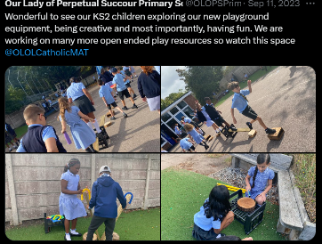  - Modify the way we plan PE lessons  - Use PE coordinator’s expertise to model/ support good PE teaching for all staff.  - Conferences and courses attended to support teaching. And staff meetings to share good practice.  - Staff meeting time to discuss the use of PE scheme (2nd year of using) and how we will use assessment. | Teachers, teaching assistants, pupils | - PE coordinator models lessons, particularly in dance, athletics and gymnastics (parkour) – staff have improved confidence to deliver lessons in their own PE time.  - Staff report they are happy with the new scheme, they particularly like the videos that show them how to set up.  - Thanks to a successful bid from ‘Learning through landscapes’ all staff benefitted from ‘loose parts’ training to support and motivate pupils during break times.  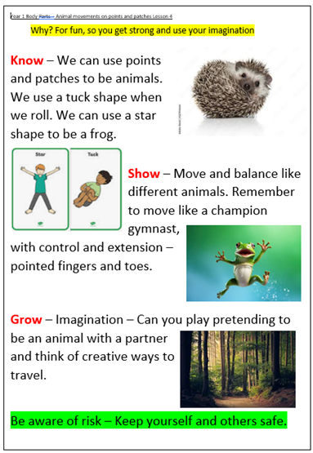  - All staff now using whole class assessment pages for PE lessons for at least 2 lessons per unit.  - PE lead attended PE conference and reported back to staff. New way of planning PE – Know, Show, Grow and whole class marking pages.  - PE lead stays up to date with research and insights and feeds back to staff in meetings and regular emails. | £5000

2. The engagement of all pupils in regular physical activity - the Chief Medical Officer guidelines recommend that all children and young people aged 5 to 18 engage in at least 60 minutes of physical activity a day, of which 30 minutes should be in school | - Top up swim for year 6.  - Extra-curricular physical activities for all children in KS 1 and 2.  - Ensure children are active for at least 30 minutes a day.  - Enhance playground resources to encourage imagination and collaborative play.  - Ensure disadvantaged children have access to a choice of equipment at break times.  - Highlight less active children and support them at break times and within PE.  - Yr 6 buddies will be trained to play and support EYFS and KS 1.  - YST survey for PE and PA to be completed.  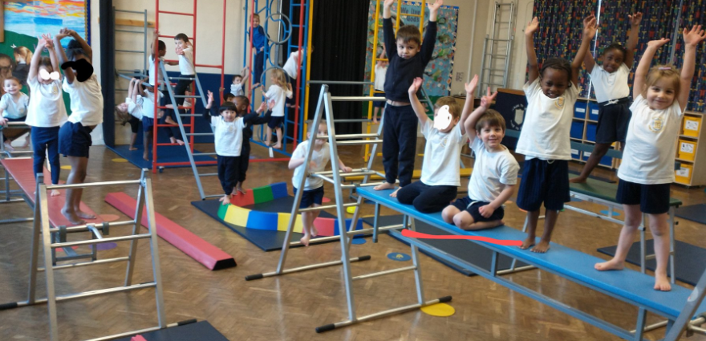 | Teachers, teaching assistants and pupils | - 70% of year 6 achieved 25m or more. We recognise this is still low, and will consider more top up time for next year’s year’s 6.  - All children have access to Extra-curricular clubs. 50% of KS 1 took part in after school activities and 70% of children in KS 2 did the same.  - All pupils took part in 2 PE lessons a week.  - 2 minutes of exercise is done at the end of every break and lunchtime on the yard, before children line up.  - Teachers do regular brain breaks in class to keep brains active. Teachers report that they like getting emails from PE lead with new ideas for this.  - All children have benefited from enhanced playground resources. Pupil voice reported that the new activities mean that playtime is more fun and children enjoy that they can work in a group.  - Pupil voice also reports that there is a good range of equipment, but they would like more balls (this is difficult because we lose a lot over the fence!).  - Year 6 buddies have been a success, and great relationships have been formed. They support play and are positive role models for younger and less able children.  - The YST survey was brilliant and provided us with excellent data. Unfortunately, not all classes took part, so results may not fully represent the whole of KS 2. We will encourage all classes to complete this next year.  - From the survey we know that:  - 92% of children know that being active is good for them.  - 87% feel good when they are active  - 77% are happy with the amount of being active they do (we will address this next year and hope to improve this figure).  - 92% enjoy taking part in PE  - 70% of pupils would like more PE  - 60% of girls would like to be active in other subjects (We will address this next year with a trial of Active Maths and English.  - 19% of boys would like more active breaktimes. (We will address this with more pupil voice and use sports ambassadors to order new equipment).  - 82% say the school encourages them to be more active. | £4500
3. The profile of PE and sport is raised across the school as a tool for whole-school improvement | - Use Sports Ambassadors from years 5 and 6 to support physical activity and provide pupil voice.  - Continue to report sporting achievements on social media, in newsletters and in bi-weekly achievement assemblies.  - Walk for water CAFOD fundraiser event.  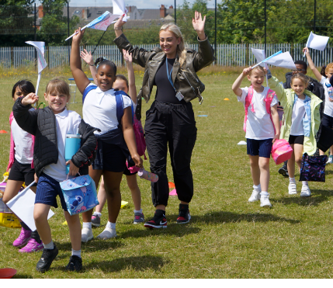  - PE coordinator to keep staff up to date with current best practice with regular emails.  - Sports day that celebrates Olympic Values for this Olympic Year.  - PESSPA display kept up to date.  - Hire the large field behind school for whole school events, football training and multi-sports after school club (we don’t have a grass area on the school grounds) | Teachers, teaching assistants, pupils and parents | - Sports Ambassadors have kept playground resources tidy and accessible for all. They have encouraged less active children to be active at break times and supported teachers in Athletics assessment lessons.    - There are A LOT of PESSPA posts on the school twitter/X account – we have done a lot this year and will keep this up.  - Parents loved joining in with the sponsored walk/run for CAFOD.  - Staff have thanked PE coordinator for regular emails and updates.  - Sports day was changed this year to reflect more of what we do within PE lessons and on the playground – eg. Gymnastics, bat and ball skills, skipping, hula hooping and football skills.  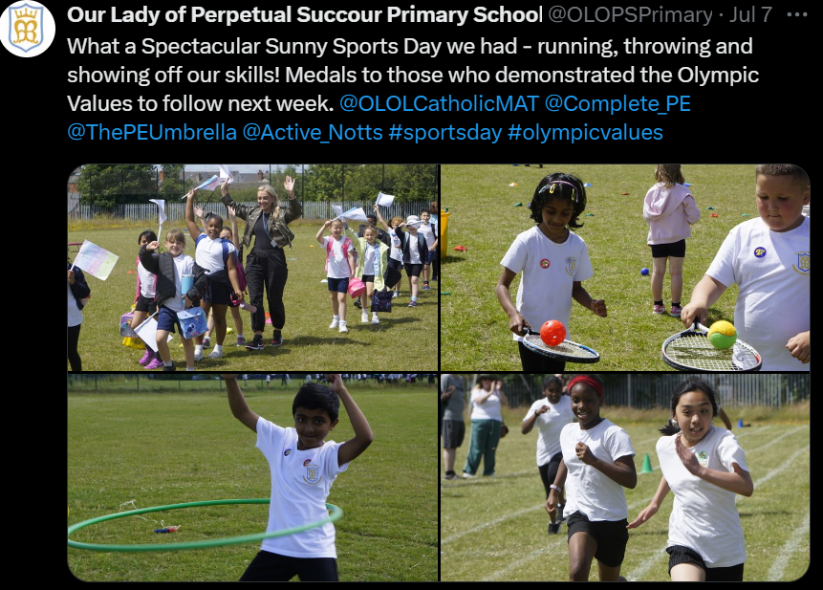  - Sports day medals were awarded for demonstrating Olympic values rather than winning races – this was well received by parents, staff and children. We will continue to do this and focus on the character curriculum and our word of the week.  - Corridor display with PESSPA photos and descriptions. We will aim to change this more regularly next year. | £1200
4. Broader experience of a range of sports and activities offered to all pupils | - Offer a range of Extra-curricular activities.  - Offer varied, fun and interesting activities in PE lessons.  - Hold a Sports activities Enrichment Day to give pupils unusual sporting opportunities.  - Invite Ash Randall, a football freestyler into school to do an assembly and workshops, to inspire and motivate pupils in the Euros (football) year.  - Year 3 University Enrichment day in Sport, health and Nutrition  - Year 2 sporting Superstars  - Year 1 Football Festival  - Tennis roadshow for all classes, to tell them a out local services and experience tennis. | Teachers, teaching assistants and pupils | - Extra curricular clubs offered included: Athletics, multi-sports, handball, dodgeball, basketball, football and New Age Kurling.  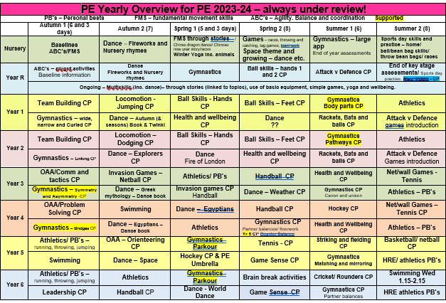  - A broad offering for curriculum sports including team building, hockey, dance, athletics and parkour. See yearly overview here…  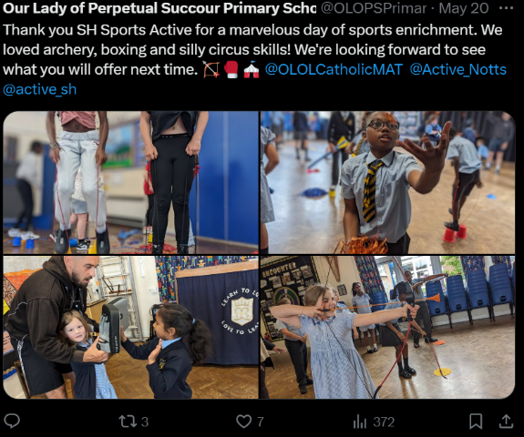  - Sports Enrichment day was amazing and gave pupils experience of archery, boxing and circus skills! See twitter post…We will be using this company next year to run an extra-curricular club offering zorbing and other unusual activities.  - We were inspired by the skills of the Euro Footballers and by World record holder, Ash Randall, in another enrichment day. Pupils then showed off their new skills during our Sports Day. See ‘X’ for our twitter post.  - Pupils in year groups 1,2, and 3 enjoyed off site visits to universities for sports festivals or enrichment days. Pupil voice showed us that these days were memorable, providing motivation and aspiration. We will continue to take part in these opportunities, providing transport for free so all children (including disadvantaged) can take part. | £2000
5. Increased participation in competitive sport | - Enter inter school events and competitions (provided by ‘School Games’ to give pupils an experience of competition.  - Provide competitive opportunities for SEN pupils by going to inclusive events.  - Encourage teachers to include an element of competitive sport within some of their units of work.  - Within athletics units, all children encouraged to beat their personal bests.  - Year 6 football team to enter a local league.  - Team A and Team B Netball teams experience Competition.  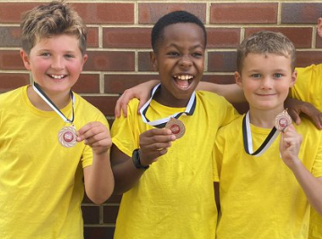 | Teachers, teaching assistants and pupils | - Teacher ‘supply’ used to take pupils to inter school sports events. This meant that 100% of pupils from years 4-6 took part in at least one event. 30% of year 3. This level of participation is now anticipated from all pupils and younger children look forward to being chosen for off-site events, so we will aim to keep up this level of participation.  - We provide free transport for all sports events so that all groups of pupils can take part (SEN, disadvantaged, girls and boys).  - Taking children to these events builds on the character curriculum we use throughout school and within PE lessons. They learn to control nerves and excitement, and experience success and failure.  - For a small school we do very well in the competitions – winning the first heat for athletics, medals for cross country running, football and netball.  - Teachers have discussed the use of PBs and competition within their lessons and some are using it effectively. We will continue to work on this next year.  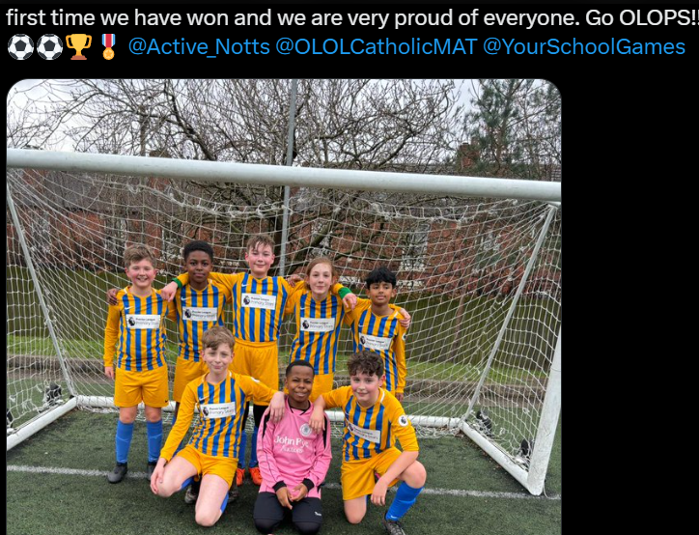  - The year 6 football team WON the league! Next year we will have separate Boys and Girls teams. | £4200

Key achievements 2023-2024
This template will be completed at the end of the academic year and will showcase the key achievements schools have made with their Primary PE and sport premium spending.

Activity/Action | Impact | Comments
- Increased resources for playground use and staff training for ‘loose parts’.  - Embed the use of character curriculum in planning for PE lessons  - PE coordinator has received regular leadership time to ensure all key indicators are met.  - Loads of sports events recorded on Twitter/ X over the year.  - Sports Enrichment days  - Renewed sports day format and medal achievements  - Provision of transport to all off-site sports events and competitions.  - Year 6 football team winning the league! | - Staff more confident to support play and physical activity during break times.  - Children are inspired and more active at playtimes.  - PE lesson planning and assessment is beginning to be included in whole class marking books, thus teachers can build on previous lessons effectively.  - PE coordinator time has meant that lots of enrichment days, sports events, competitions, extra curricular events can take place. Also, that staff can be kept up to date with best current practice, as recognised by leading PE organisations.  - A more exciting and inclusive Sports day was enjoyed by all.  - Offering free transport to all sports events meant that all minority groups were able to access a wide range of sports events.  - More children are keen to join a football team and we will have a girls and a boys team next year. | - We plan to build on the success of ‘loose parts’ and use pupil voice to expand this further.  - PE coordinator has a secondment to write PE lessons for the Oak Academy, employed by ‘PE Scholar’. This means that best up to date lesson plan format and content can be shared with all staff in school (and beyond to the OLOL academy trust).  - We took part in approximately 30 inter school events this year, meaning all children in year’s 4-6 took part in at least one off-site event.  - There are so many PE lessons and sports events recorded on Twitter and this has rained the profile of PESSPA.  - We are a small, one form entry school, so winning the football league and any sporting events is a major achievement because we are often up against schools with 3 or 4 form entries.

Swimming Data
Meeting National Curriculum requirements for swimming and water safety.
Priority should always be given to ensuring that pupils can perform safe self-rescue even if they do not fully meet the first two requirements of the National Curriculum programme of study

Question | Stats: | Further context  Relative to local challenges
What percentage of your current Year 6 cohort can swim competently, confidently and proficiently over a distance of at least 25 metres? | 70% | We are still catching up from swimming lessons missed from the pandemic.  The cost of buses for swimming lessons has rapidly increased, making it difficult to offer lessons to everyone every year.
What percentage of your current Year 6 cohort can use a range of strokes effectively [for example, front crawl, backstroke, and breaststroke]? | 70% | This is children who can swim 25 m on their front or back.  The figure of children able to swim 10m on front and back is 80%

What percentage of your current Year 6 cohort are able to perform safe self-rescue in different water-based situations? | 70% | Only 70% could perform self-rescue in a range of circumstances without the use of aids.  100% of children received water safety lessons, and could perform a self-rescue with equipment.
If your schools swimming data is below national expectation, you can choose to use the Primary PE and sport premium to provide additional top-up sessions for those pupils that did not meet National Curriculum  requirements after the completion of core lessons. Have you done this? | Yes, year 6 had a half term of swimming lessons at the end of the year.
Have you provided CPD to improve the knowledge and confidence of staff to be able to teach swimming and water safety? | No, but we use qualified instructors at the local pool for teaching swimming.

Signed off by:

Head Teacher: | Fiona Wadsley
Subject Leader or the individual responsible for the Primary PE and sport premium: | Sarah Herbert PE Coordinator
Governor: | (Name and Role)
Date: | 20th July 2024

