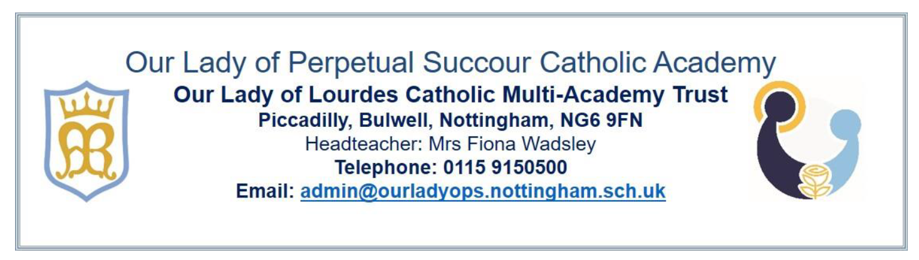

# Special Educational Needs – Annual Report 2024

**Our Mission**

At Our Lady of Perpetual Succour Catholic Academy we **learn to love and love to learn.** We are a Catholic community, guided by the light of Christ and working in partnership with parents and parish, where every member is encouraged to grow in their faith and give witness to others.

We are an exciting learning community where **every child is given the opportunity to enjoy reaching their full potential** – intellectually, spiritually, physically and creatively.

We are a loving community where each person is cared for as a unique gift from God and can grow socially and emotionally in a happy and safe atmosphere of mutual love and respect.

**Our School Vision for SEND**

At Our Lady’s school we aim to enable all children to achieve their full potential and to be included fully in our exciting and stimulating school life. All children are supported in growing physically, socially, emotionally and intellectually within an inclusive environment.

Our school believes that with appropriate provision, every child with a special education need or disability, can have aspirational targets which build on their strengths, and opportunities to develop their areas of need. We strive hard to offer appropriate support daily in school and work closely with parents, and where needed, outside agencies, to assess, plan, ask questions, make decisions, review processes and provide for each child’s individual needs.

We have an ambitious curriculum and use adaptive teaching to ensure high ambitions for all pupils including those with SEND.

**What is SEND?**

SEND stands for Special Educational Needs and Disabilities. There are four broad categories of SEND as stated in the Code of Practice (2014):

* Communication and Interaction (including autism and speech and language disorders)
* Cognition and Learning (including dyslexia, dyspraxia, and moderate learning difficulties)
* Social, Emotional and Mental Health (including ADHD and attachment disorders)
* Physical and Sensory (including vision and hearing impairments)

At different times during their school life, a child may be identified as having a special educational need. This means they have a learning difficulty or a disability which requires special educational provision which is additional to or different from the provision offered through quality first teaching in the classroom. The SEND register is a list of such children who need additional support within the school environment. Children will only be added to, or removed from, the SEND register after consultation between the school SENCO, class teacher and parents.

At Our Lady of Perpetual Succour we provide for the needs of pupils with*:* Communication and Interaction, including ASD; Cognition and Learning, including dyslexia; Social, Emotional and Mental Health, including ADHD and Sensory and Physical. **We currently have 26 children on our SEND register, including one child with an EHCP and three children who qualify for Higher Level Need funding (HLN). 9.2% of children on roll have SEND compared to a national average of** **17.3%.**

The table below shows the number of children with each primary need at Our Lady of Perpetual Succour

|  |  |  |  |
| --- | --- | --- | --- |
| **Primary Need** | **Total children** | **% of total SEND children** | **Change**  **since 2022** |
| **Communication and Interaction** | 11 | 42.2% | Increase  of 10% |
| **Cognition**  **and Learning** | 7 | 26.9% | Increase  of 4.4% |
| **Social, Emotional Mental Health** | 6 | 23% | Decrease  of 15.7% |
| **Physical and/or Sensory** | 2 | 7.6% | Increase  of 1.2% |

**Who is responsible for my child’s special educational needs in school?**

Staff in our school work as a team to support children. Class teachers are responsible for a child’s learning and provision. SEND is co-ordinated and managed by the school SENCO, across school from Nursery to Y6. The school governing body support the SENCO and Head Teacher in ensuring appropriate provision is available for all children in our school.

The link governor for SEND at our school is **Deacon Martyn Swaby**, who is also the Chair of Governors.

**The SENCO in our school is:**

Mrs K Thompson

Email: [senco@ourladyops.nottingham.sch.uk](mailto:senco@ourladyops.nottingham.sch.uk)

Telephone number: 0115 9150 500

**SENCO responsibilities include:**

* Overseeing day to day implementation of the school SEND policy
* Coordinating provision for children with special educational needs and ensuring school SEND records are up to date
* Liaising with parents of children with SEND
* Advising and offering support and training to staff members to ensure staff have adequate knowledge and understanding of SEND in order to effectively meet pupils’ needs.
* Utilising support from outside agencies, such as the city SEND service and health care professionals to identify need, seek advice and support for pupils and families
* Managing the transition process as children move into school, between phase within school and on to secondary school

**Class Teacher responsibilities include:**

* Having high expectations for every child in their class including those with special educational needs and disabilities
* Building on what each child already knows, can do and their personal strengths
* Adapting their teaching and strategies so that each child is fully involved in learning in class.
* Carefully checking each child’s progress and recognising if a child needs extra support to help them make the best possible progress
* Agreeing, setting, reviewing and sharing each child’s Individual targets once a term with parents/carers.
* Working with support staff to plan, implement and review adaptive teaching strategies and interventions to meet individual needs.
* Using ‘additional to or different from’ strategies for motivation and management of each child’s behaviour (if appropriate).

**Identifying Special Educational Needs at our school**

When a child joins OLOPS, either in nursery, reception or any other year group, we gather information from parents, previous settings and any outside agencies involved with the child. Admission to school from reception to year 6 is through accessing the local authority admissions portal; the school admissions over subscription policy can be found on the school website.

All teachers are teachers of SEND and are responsible for communicating with parents and the SENCo to identify children with potential special educational needs. At Our Lady of Perpetual Succour Primary Academy we believe early, timely intervention is best and we use a graduated approach to help us identify children with SEND. A document containing further information about our graduated approach can be found in Appendix 1.

Should a parent have concerns about the progress their child is making or about their child’s educational needs, we advise you to speak to you child’s class teacher initially, who will then liaise with the school SENCO. At this point, the SENCO and the class teacher will begin the graduated response with an initial assess, plan, do, review cycle. This will happen in collaboration with parents/carers at each stage.

Teachers use assessment grids in all subjects to ensure children are working towards the yearly targets for English and Maths. These assessments may also include P level, pre key stage assessments and PIVATS.

This on-going assessment forms part of end of term assessments results which are monitored by SLT and give information about progress.

**Consulting with parents of children with SEND**

We believe teamwork is the best way to support our children, therefore we work closely with parents and any relevant external agencies. Once a child is identified as having SEND and support is put in place, parents/carers are invited to join the school team in termly meetings in school during which their child’s progress is discussed, current targets are reviewed, new targets are set and further actions are discussed. Parental views are gathered during such meetings using a parent voice questionnaire and through attendance at meetings. Parent’s Evenings provide further opportunities for parents/carers to discuss their child with the class teacher and SENCO, and parents are welcome to contact the class teacher if they have concerns or questions.

We keep parents up to date with SEND developments in school and in the community through a termly newsletter.

**How SEND children contribute their views**

Each child has the opportunity to share their views on their targets, progress and aspects of school life before each termly review*.* Staff use Routes 2 Inclusion pupil questionnaires to support children in this process. Children are aware of their targets and teachers regularly discuss their progress and provision with them. Children on the SEND register have regular check ins and are encouraged to participate in wider opportunities in school life, such as Faithful Friends and School Council. We believe every child can actively contribute to the wider life of the school and it is equally important for pupils with SEND to have the opportunity to make a valuable contribution through after school clubs and roes of responsibility. Our school is inclusive and therefore we ensure all our children’s voices are heard within our school and community.

**Consulting with outside agencies**

Our school works collaboratively with outside agencies to support children with SEND and their families. Sharing knowledge and information with our support services is important for effective and successful SEND provision for our children. Such agencies include Behaviour Support Team and Autism Team. Other services accessed by school include Community Nursing Team, Speech and Language Therapists and Occupational Therapists.

**Our approach to teaching children with SEN**

We deliver an exciting, stimulating and creative curriculum using a wide range of teaching methods to meet the needs of all learners. Lessons are pitched at an appropriate level to ensure children can access them and retain knowledge taught but are challenging and ambitious, motivating children to reach their full potential. If a child is identified as having a special educational need, we recognise the need and provide support which is additional to or different to their peers as part of the quality first teaching we offer. Examples include group interventions, personalised intervention, flexible grouping, additional modelling of tasks, practical resources and ~~increased~~ additional adult support where necessary. In some cases, a child may require a high level of adult support and a curriculum which is personalised to meet their needs. These children may be receipt of Higher Level Funding (HLN) and/or have an Education Health Care Plan (EHCP).

A copy of our whole school provision map can be be found in Appendix 2.

The Catholic ethos of our school actively promotes inclusion and equity in recognising that everyone is created as a gift from God in his image and likeness. We celebrate differences and value the contribution that each individual makes to the whole community. Displays, resources and books reflect the diverse nature of our world and school community so every child can see themselves as a valued member of the community.

**Learning environment adaptations/accessibility**

We continuously review our school environment and make reasonable adjustments for pupils with disabilities so they can take advantage of the education, benefits, facilities and services we offer. Our equality policy and academy equality objectives ensure pupils with disabilities are not treated less favourably than other pupils.

The school has a range of SEND facilities in place including a disabled toilet, facilities for changing and wheelchair access to the building. Designated areas have been painted yellow to support visual impairment and participation.

The school accesses support from the sensory team for any children with visual impairments or hearing impairments. In addition, PDSS (Physical Disabilities Specialist Services) or Occupational Health may support with equipment and improving facilities.

**Support for improving social emotional development**

Every child in our school community is nurtured and cared for by our team of highly trained, empathetic staff. We are committed to supporting every child’s emotional wellbeing and helping our children to develop the skills and knowledge to recognise the importance of their own mental health and be able to care for it. We are a Mental Health Support Team (MHST) school and work with our allocated practitioner to promote positive mental health and wellbeing for everyone in our school community, including children, staff and families. We offer interventions with our ELSA (Emotional Literacy Support Assistant) and targeted support from our MHST practitioner, alongside interventions such as Lego Therapy and extra-curricular activities such as Wellbeing Club. Class teachers encourage children to complete an ‘emotional check in’ at regular intervals during the school day, which encourages conversations between staff and children about wellbeing, and each class enjoys regular mental health work out sessions.

All staff continually monitor the emotional wellbeing of the children in our care and discuss any concerns with the school SENCO and with parents.

**Evaluating the effectiveness of Provision**

We endeavour to implement sufficient support to enable our children to reach their true potential and meet their targets. The school identifies the needs of children with SEND on a provision map. This identifies all the support provided and is reviewed regularly. Challenging and achievable targets are set with children and interventions are used to help children make progress and move closer to achieving their target. Progress against targets is monitored by the class teacher, by the SENCO and other Senior Leaders with input from parents/carers. This is ~~reported to~~ discussed and shared with parents and families termly and together, as a team around the child, we work through the assess, plan, do, review cycle.

We assess the effectiveness of our provision through regular monitoring of: progress data, pupil’s books, observing pupils in lessons, taking pupil voice, termly meetings with parents/carers, feedback from external agencies, reviewing the impact of interventions used to support pupils, discussion with staff.

**Transition Arrangements**

EYFS staff and a member of the Senior Leadership Team will meet with parents prior to their child starting Nursery or Reception and will also conduct a home visit to ensure smooth transition for our children as they join us. School senior leaders will receive information from prior educational settings for children who join us in all year groups. If required, the SENCO will liaise with the previous setting to discuss an individual child’s needs. The same process is applicable for children leaving us to attend another primary school.

To support children leaving us at the end of Y6 to begin their secondary school education, the Y6 class teacher, along with the SENCO, attends Primary Transition meetings to discuss specific needs of our children with staff from the relevant secondary establishments. Our children benefit from both focused transition learning during their time in Y6 and a number of transition days at the secondary school they will attend.

Children moving classes within school are given the opportunity to take part in ‘class swap’ days, to meet their new teacher and spend time in their new classroom. Information is passed from one class teacher to the next through in house transition meetings. The school SENCO attends these meetings to ensure appropriate information is passed on for each child with SEND to their next teacher.

**Staff Training**

School staff keep up to date with relevant developments and legislation through both in house and external training. The SENCO attends relevant training courses throughout the year, including OLOL Trust SEND networks and ‘Family SENCO Meetings’, designed to support SENCOs in their role and disseminate information regarding current practice to staff. The SENCO, alongside other members of the leadership team, ensures training for staff matches the needs of the children in our school and school development priorities. All teaching staff have received Autism Awareness and Makaton (a version of sign language) training delivered by the autism team and are trained in using Routes to Inclusion, delivered by the R2I core team. All staff have regular safeguarding training, which addresses areas such as vulnerable children including SEND pupils, and a number of staff have accessed moving and handling pupils training. All teaching and support staff have received de-escalation training.

**SEND Action Plan**

During the academic year 2023-2024, the following actions were outlined for SEND across the school. Each action has been evaluated in green:

1. To improve procedures for identifying SEND children are effective and that staff then follow a graduated response. The SENCO produced a graduated response plan and staff were trained on this. An entry and exit document was produced to guide staff in adding updating the SEND register.
2. To ensure interventions for SEND children are well managed and effective. All teachers and teaching assistants received training on planning and managing interventions through our Assess, Plan, Do, Review cycle. The SENCO monitored the provision by conducting learning walks and overseeing intervention record sheets.
3. To promote positive emotional wellbeing by creating a culture of mental health. Alongside an MHST practitioner, we offer whole school assemblies, whole class workshops, small group interventions and 1:1 support, in addition to participating in Mental Health Week. Each class has a worry monster and children have emotional check ins through the day and weekly mental health workouts. We have extended our culture of mental health to families by hosting a mental health and wellbeing coffee morning, creating a mental health noticeboard and including information about mental health and wellbeing on our termly SEND newsletter.

The following actions were outlined for SEND, 2024-2025:

1. To provide relevant children with a personalised pre-formal curriculum through the development of Enhanced Provision.
2. To ensure curriculum adaptations allow SEND children to access lessons alongside their peer group most of the time and for most children.
3. To respond to the speech, language and communication needs of children in our school, including SEND children and our youngest children, by developing improved methods of identifying need and addressing need through intervention.

**Where is the Local Offer published?**

A link to Nottingham City’s Local Offer can be found on the SEND section of our website.

[Special Education Needs & Disabilities Local Offer | Ask Lion - Nottingham City Directory](https://www.asklion.co.uk/kb5/nottingham/directory/landing.page?directorychannel=7)

**Concern or Complaints**

In the first instance we ask parents to please speak with your child’s class teacher if you have a concern or complaint. If after having this conversation, you still feel your query hasn’t been resolved, the SENCO or Head Teacher can be contacted. Please call in to the office or telephone to request an appointment. The school complaints policy can be accessed on the school website, through this link: [Complaints-Procedure-TRUST-FINAL-Dec-2021-extended-review-date-.pdf (ourladyopsbulwell.com)](https://www.ourladyopsbulwell.com/wp-content/uploads/sites/15/2024/03/Complaints-Procedure-TRUST-FINAL-Dec-2021-extended-review-date-.pdf)

Alternatively, a paper copy can be made available to you through the school office.

**Appendix 1 – Graduated Support**

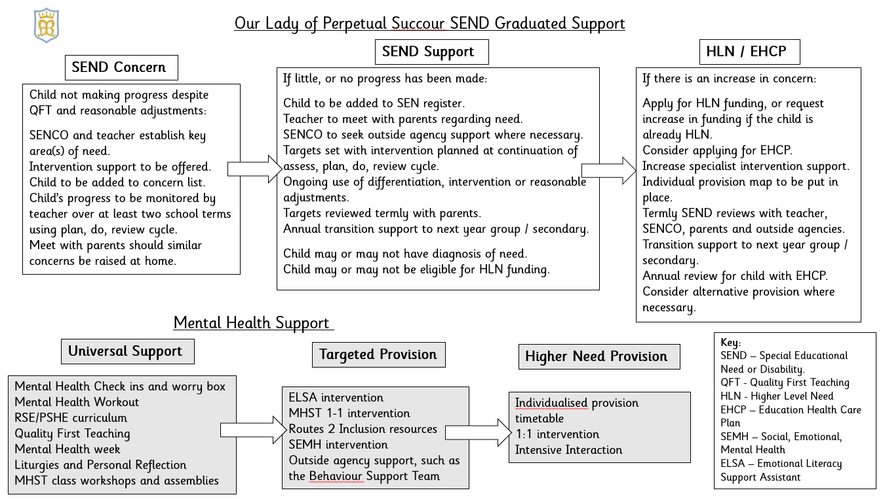

**Appendix 2 – Whole School Provision**

