**Issue 04 March 2024**

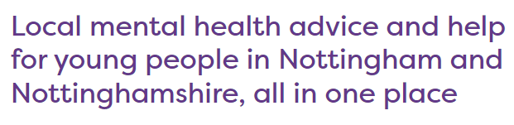

# Chicks in School!

Animals play a therapeutic role in our lives and the benefits for SEND children, in particular, are well documented. Caring for animals develops our life skills, builds our communication skills, develops our sense of empathy and provides us with companionship.

All of our children, but particularly our SEND children, are overjoyed to be caring for our baby chicks in school at the moment!

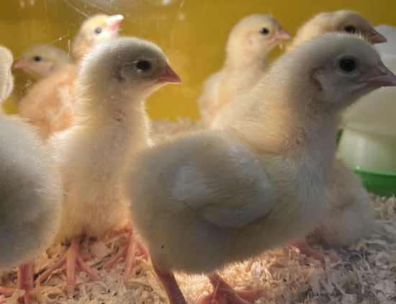 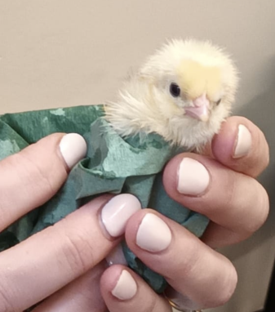

visit specialneedsjungle.com for more information about the benefits of pets for SEND children

nottalone.org.uk



Crisis Line for

urgent support:

**0808 196 3779**

# An Update from the Mental Health Support Team

The Mental Health Support Team (MHST) in Nottingham City is part of an NHS funded national project. The team offers a collaborative, system-wide approach to support the mental wellbeing of children.

In July 2023 we were delighted to become a MHST school and welcomed our allocated practioner, Mandy Lau. Mandy works with children of all ages in our school. She offers staff traning, class workshops, group interventions and even a lunchtime wellbeing club!

Our children love working with Mandy and the feeling is mutual….

*“I thoroughly enjoy working with Our Lady of Perpetual Succour Catholic Primary Academy. The pupils are incredibly kind, courteous, and inclusive. It's clear that the staff prioritise the well-being of the children as a central principle of the school's values.”* Mandy

We thank Mandy for her continued support and hope our partnership will continue for a long time to come!

 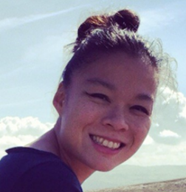

# Welcome to our SEND newsletter

A very warm welcome to the latest copy of our SEND newsletter. This newsletter shares updates and information regarding special educational needs and disability, both at our school and in the community.

Should you require any further information, or if you would like an appointment to discuss your child, please contact the school office and I will be happy to help.

Mrs Thompson

SENCO

# SEND Frequently Asked Questions

What is neurodiversity?

The term “neurodivergent” describes people whose brain differences affect how their brain works. That means they have different strengths and challenges from others. Differences include medical disorders, learning disabilities and other conditions. Possible strengths include strong memory, being able to mentally picture three-dimensional (3D) objects easily and the ability to solve complex mathematical calculations in their head.

Page 1 0115 915 0500 I [Email office](mailto:admin@ourladyops.nottingham.sch.uk) I [Website](https://www.ourladyopsbulwell.com/)

**Mrs F Wadsley, Headteacher** 0115 915 0500 I [Email the office](mailto:admin@ourladyops.nottingham.sch.uk) I [Website](https://www.ourladyopsbulwell.com/)

**Easter Holiday Community Activities**

# 

Page 2 0115 915 0500 I [Email office](mailto:admin@ourladyops.nottingham.sch.uk) I [Website](https://www.ourladyopsbulwell.com/)

# Free Autism Training for Parents

Autism East Midlands has developed a range of training courses and workshops for the families of autistic individuals of all ages. Upcoming workshops include:

* Tuesday 16 April - Introduction to Autism
* Tuesday 21 May - Autism and Girls
* Tuesday 18 June - Promoting Positive Behaviour
* Tuesday 16 July - Autism and Sensory Differences
* Wednesday 14 August - Autism and Schools
* Wednesday 11 September - Autism and Claiming Disability Living Allowance

**Time:**Varies, but usually 7-8.30pm on a weekday evening

**Location:** Online over Zoom

**Cost:** Free to attend

**Suitability:** Parents/carers of children under 18

**To join:**If you would like to join a workshop, please email[**lesley.lock@aem.org.uk**](mailto:lesley.lock@aem.org.uk)

For further support, visit autismeastmidlands.org.uk



**Express Yourself Holiday Activities Club – Bookings Now Open!**

**Monday 8th April – Thursday 11th April 2024**

Sessions will run from 10am – 2pm for children and young people ages 5 – 18 years old.

Limited FREE places for Nottinghamshire children and young people who are entitled to free school meals and for SEND children and young people



Look Inside Sensory Learning & Play

David Lane, Basford

[07424 038353](tel:07424038353)

Lookinside.org.uk

A beautiful quote to finish…..

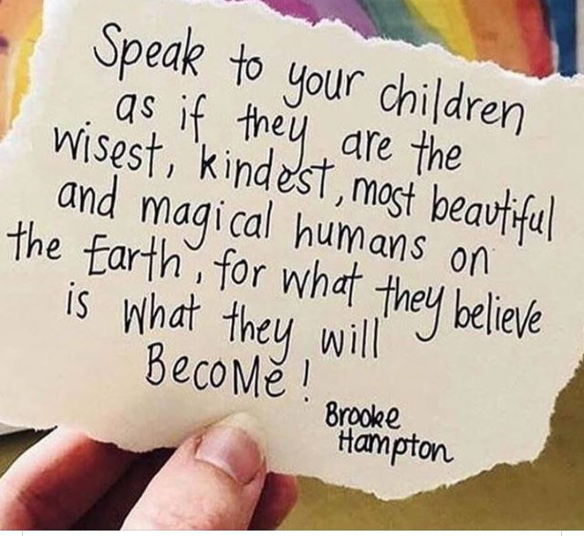

**A final thought…**

**Butterflies can’t see their wings.**

**They can’t see how truly beautiful they are, but everyone else can.**

**People are like that too.**