**Issue 03 October 2023**

The children will identify emotions, explore how emotions make us feel and behave, and learn strategies to regulate our emotions. Each class has been allocated a colour and we hope to see children wearing clothing or something in their hair which reflects their class colour. See Arbor or your child’s teacher for more information.

We anticipate the day will be lots of fun, but also a fantastic opportunity for us to learn more about mental health.

# SEND Frequently Asked Questions

Is ADHD a form of Autism?

Autism Spectrum Disorder and ADHD are related in several ways. ADHD is not on the autism spectrum, but they have some of the same symptoms. Having one of these conditions increases the chances of having the other. Both conditions/disorders can affect the central nervous system, which is responsible for movement, language, memory, and social and focusing skills.

World Mental Health Day is fast approaching - Tuesday 10th October, which will be a non-uniform day for our children!

We have planned our day around the book, ‘The Colour Monster’.

# Our Lady’s joins the Mental Health Support Team!

The Mental Health Support Team (MHST) in Nottingham City is part of an NHS funded national project. The team offers a collaborative, system-wide approach to support the mental wellbeing of children, and we are delighted to become one on the 46 Nottingham City schools involved in the project!

MHST offer interventions that have been shown to help support children overcome difficulties with their mental health and wellbeing.  These can be offered on a 1-1 basis, as part of a small group, or with parents and caregivers.

MHST can also support whole school approaches and are happy to offer assemblies and workshops for classes. Our children in Y1-Y6 have aready enjoyed their ‘Introduction to Mental Health’ workshop in the summer term of last academic year.

The majority of the MHST interventions use Cognitive Behavioural Therapy approaches.  Cognitive Behavioural Therapy is a type of therapy that focuses on your thoughts, feelings and behaviour and how these three things interact.

We hope that working in partnership with MHST will benefit the wellbeing of our children, now and in the future.

 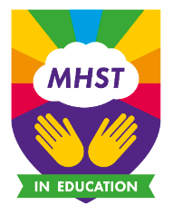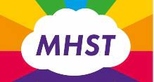

# Join us for a SEND Coffee Afternoon

Monday 11th December 1:00 – 2:30pm

A great opportunity for you to chat to other parents of SEND children, over a coffee and biscuits.

Sarah Golding, of the SEN support team, will join us to provide strategies for parents with ASD children, chat informally, and is even happy to offer us a Q & A session.

Come and join us!  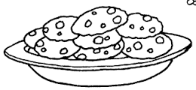

# World Mental Health Day

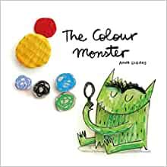

# Welcome to our SEND newsletter

A very warm welcome to the latest copy of our SEND newsetter, and the first of the new academic year! This newsletter shares updates, calendar events and information regarding special educational needs and disability, both at our school and in the local community.

Should you require any further information, or if you would like an appointment to discuss your child, please contact the school office and I will be happy to help.

Mrs Thompson

SENCO

Page 1 0115 915 0500 I [Email office](mailto:admin@ourladyops.nottingham.sch.uk) I [Website](https://www.ourladyopsbulwell.com/)

**Mrs F Wadsley, Headteacher** 0115 915 0500 I [Email the office](mailto:admin@ourladyops.nottingham.sch.uk) I [Website](https://www.ourladyopsbulwell.com/)

# 

# Lego Therapy to continue in school this year

Following the success of Lego Therapy, provided by a local outside provider last academic year, we are delighted to be continuing sessions this year. Some children in Key Stage 1 and in Key Stage 2 have already started sessions with two of our Teaching Assistants, Mrs Hand and Mrs Pawlack.

Lego Therapy is a social development programme, which helps children with social interaction, language development, friendships and confidence. Lego Therapy is proving to be a great success and we aim to continue using this therapy to support more children in the future!



‘Ask Us Nottinghamshire’ is a free, confidential Information, Advice and Support Service, to give impartial advice,

information and support across education, health and social care issues to parents and carers of children with special educational needs and disabilities (SEND) living in Nottinghamshire.

Askusnotts.org.uk Tel: 0800 121 7772

# Local Support Services for Parents of SEND Children

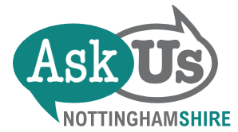

A lovely thought to leave you with…

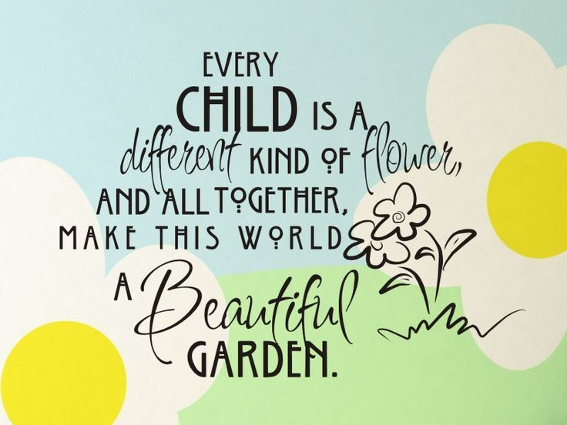

# Autism Support Services

The Local Authority SEND Team continue to provide support for parents of children with ASD through their

free-of-charge sessions and workshops.

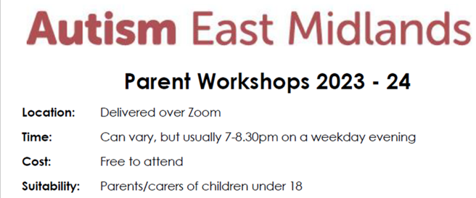

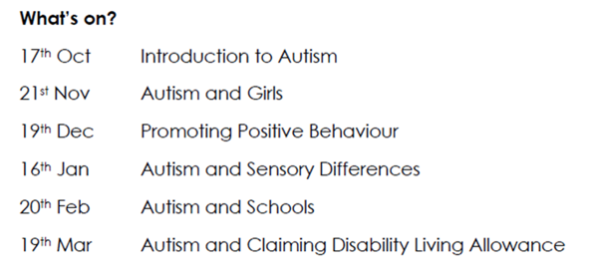

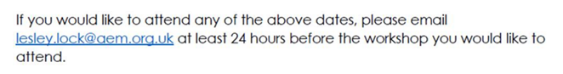

Page 2 0115 915 0500 I [Email office](mailto:admin@ourladyops.nottingham.sch.uk) I [Website](https://www.ourladyopsbulwell.com/)