Handwriting Policy

Intent

Handwriting is an important skill which, like reading and spelling, affects written communication across the curriculum. Handwriting contributes to writing ability because legible writing that can be produced comfortably, at speed and with little conscious effort allows a child to attend to the higher-level aspects of writing composition and content. It also contributes to reading fluency because it activates visual perception of letters.

At our Lady of Perpetual Succour Catholic Primary Academy we aim to:

* Teach handwriting regularly and systematically
* Use a consistent approach to teaching handwriting
* Adopt a consistent approach to handwriting by staff who write in children’s books and on displays/whiteboards
* Teach children to develop neat, legible handwriting which they can produce with ease and at speed
* Enable children to produce well-presented written work that they can feel proud of

Implementation

Children will be taught to:

* Hold a pencil correctly, using a tripod grip as shown below

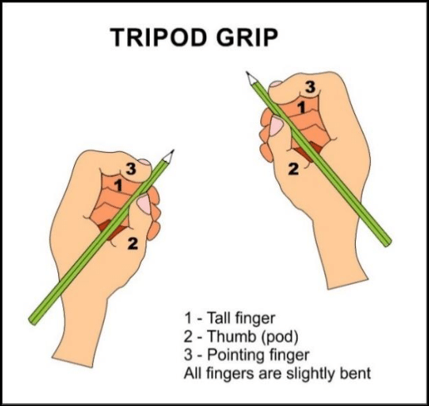

* Adopt the correct posture when writing, as shown below. For left handed pupils, the book should be tilted slightly towards the right hand

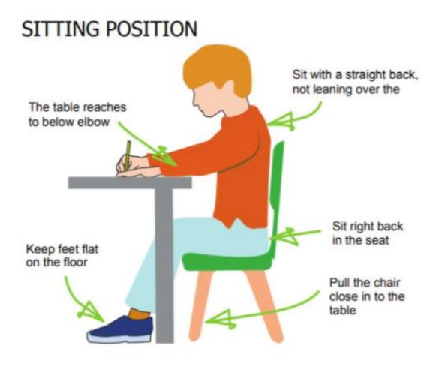

* Write from left to right and from top to bottom on the page
* Use spacing between words which reflects the size of the letters
* Form regularly sized and shaped lower-case and upper-case letters from Nursery to the end of Key Stage 1, using the Little Wandle scheme, as the example below shows. Lower and upper case letters are taught in the order suggested by the Little Wandle scheme (See Appendix 1)
* Know the entry and exit points of each letter
* Use diagonal and horizontal strokes needed to join letters and to know which letters are better left not joined, including all capital letters.
* Join handwriting in a cursive style from Y3 onwards

The cursive script agreed at Our Lady of Perpetual Succour is shown below. Lead in strokes are not used for any letter or digit.

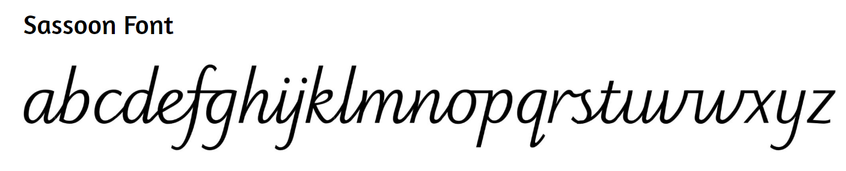

* Letter formations and joins will be modelled to children with vocalization explaining how to complete the formation. Once joins have been introduced during systematic handwriting lessons, children may then practice the formation by independently copying from the board.

See Appendix 2 for the suggested lesson order in teaching joined cursive handwriting for Key Stage 2.

* A looped lower case letter k is taught from Y3 onwards, encouraging a continuous flow when joining the letter.

Handwriting Progression Nursery to Year 6

|  |  |  |  |
| --- | --- | --- | --- |
| Nursery | Reception | Year 1 | Year 2 |
| Children will be introduced to:   * Fine motor activities to strengthen hand control * A range of mark making media * Activities to develop pre-writing shapes * Visualizing and matching pre- writing shapes * Drawing shapes independently * Letters in their own name * Little Wandle set 1 letters | Children will be taught to:   * Sit at a table with correct posture * Hold a pencil using a correct pencil grip * Begin to form lower case letters in the correct orientation, using correct entry and exit points * Begin to form capital letters correctly * Begin to form digits 0-9 * Use spaces between words * Write on a line | Children will be taught to:   * Sit at a table with the correct posture and hold a pencil with the correct pencil grip * Form lower case and capital letters in the correct orientation using the correct entry and exit points * Form digits 0-9 * Know the terms tall letters, short letters, ascenders and descenders * Understand which letters belong to which letter families * Use spaces between words * Write on a baseline | Children will be taught to:   * Form lower case letters of the correct size relative to one another * Form digits and upper-case letter of the correct size relative to one another and to lower case letters * Use space between words which reflects the size of the letters * Write on a base line with a second line marking descenders and a third line making ascenders |
| Year 3 | Year 4 | Year 5 | Year 6 |
| Children will be introduced to and taught to:   * Join letters using diagonal and horizontal strokes * Understand which letters are best left not joined, including capital letters * Increase the legibility, consistency and quality of handwriting * Improve accuracy in writing on a base line with a second line marking descenders and a third line making ascenders | Children are taught to:   * Use diagonal and horizontal strokes needed to join letters with increased independence * Know which letters are not joined, including all capital letters * Increase the consistency, fluency and legibility of handwriting | Children are taught to:   * Independently use diagonal and horizontal strokes needed to join letters * Know which letters are not joined, including all capital letters * Increase the consistency, fluency and legibility of handwriting | Children have opportunity to:   * Practise and refine known joins * Increase the consistency, fluency and legibility of handwriting   Pupils judged to be working ‘at the expected standard’, or ‘at greater depth within the expected standard’, must evidence joined handwriting, although not necessarily in every piece of writing.  There is no requirement for handwriting to be joined for the ‘working towards’ standard. |

Support

Some children may receive extra support with handwriting. Such support may include:

* Extra handwriting lessons as intervention and small group sessions
* Increased adult support during handwriting lessons
* Delayed teaching of joining
* Use of a pencil grip
* Increased practice at home, supported by parents/carers

Assessment

Children are taught to join using a cursive style from Year 3 onwards. Once a child’s handwriting (Key Stage 2) is legible, joined, neat and fluent; consistently demonstrated across all curriculum areas, they will be awarded a pen licence and be able to write with a school issued handwriting pen. At the end of each academic year, or if a decline in the quality of their handwriting is noticed during the year, the pen licence expires.

We emphasise constructive feedback and live marking techniques. Mistakes and misconceptions are corrected by a staff member, and modelled using a green marking pen.

Our chosen handwriting style should be used consistently throughout the school and be evident on display boards and in children’s work.

Appendix 1: Little Wandle Lower Case Letter Formation Guide

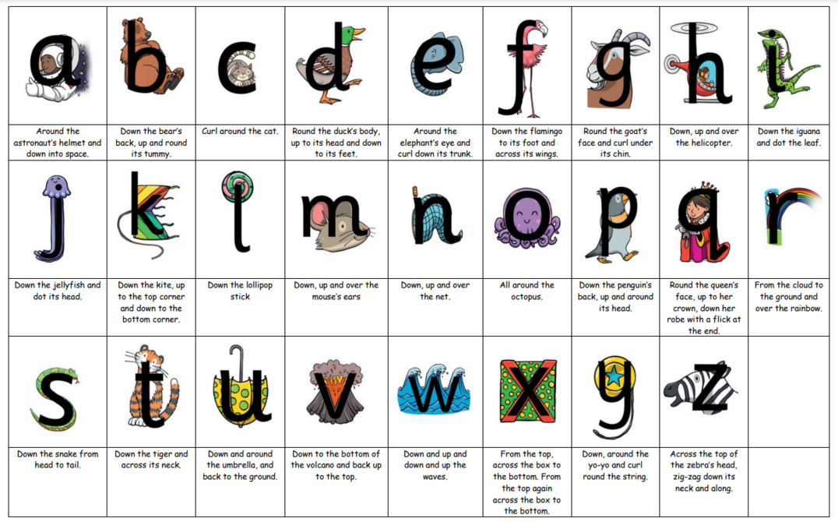

Appendix 1: Little Wandle Upper Case Letter Formation Guide

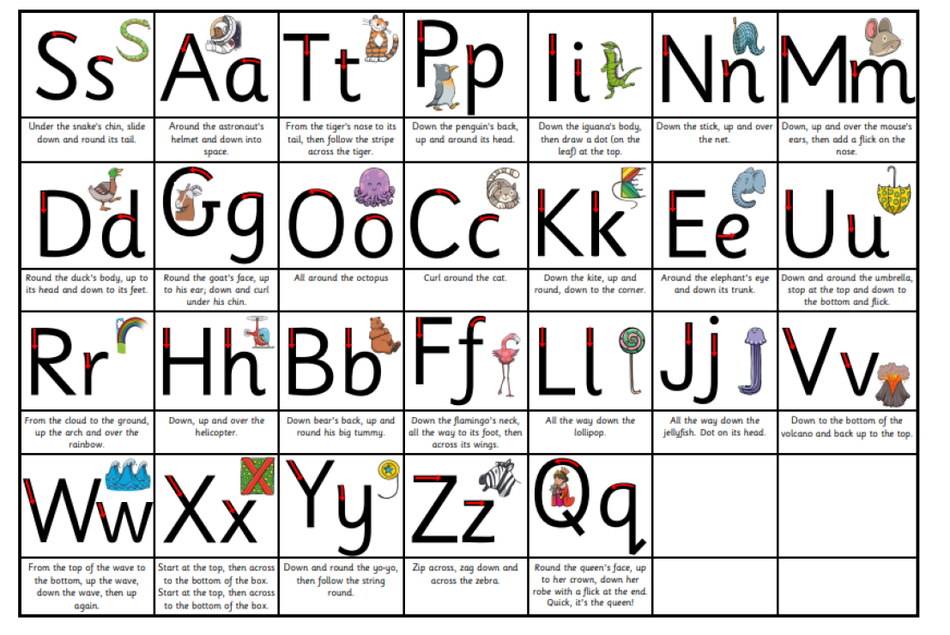

Appendix 3: Suggested order of teaching joined cursive handwriting for Key Stage 2

|  |  |  |  |
| --- | --- | --- | --- |
| Year 3 | | Year 4 | Year 5 & 6 |
| Stage 1 | Baseline Joins:  il, th, hi, lu, in, mu, un | Recap of Y3 Stage 1-3 | Children are taught handwriting through:  spellings, synonyms, homophones, direct speech, reported speech, punctuating sentences, story openings, story endings, paragraphs |
| Stage 2 | Round Joins:  cc, ca, ds, ad, ea, ee, as, de, sc, da | Number names |
| Stage 3 | Top Joins:  oo, on, oc, oa, or, ol, ri, re, ov, wh, wa, we, rd, os, ro, | Days of the week and months of the year |